## 

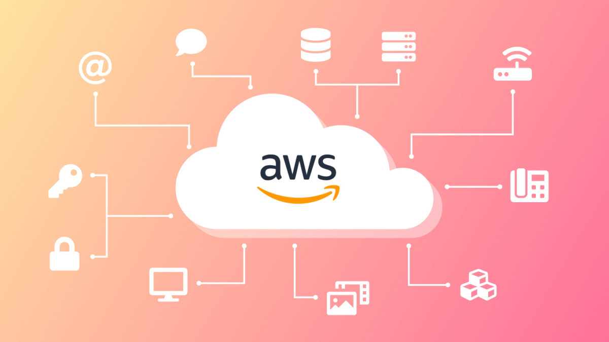

Technical design | Cloud migration

16/05/2024

Overview

A detailed design and firm costs to migrate our critical line-of-business

application PETRA to the Amazon Web Services cloud. Including annual AWS cloud costs and cost of support.

# Design Diagram

The diagram is not 100% complete because of the shape limit on lucidchart.

# Thoughts behind the design

This is a three tier application that consists of a web layer, application layer and database layer. The web layer will be within a public subnet and have an Ec2 instance that will be running on the Microsoft windows server 2008 AMI. The application layer will be within a private subnet also running on the Microsoft windows server 2008 AMI. There will be a route table directing to the NAT gateway. The database layer is within a private subnet and contains a RDS (microsoft SQL server).

All of the above is across 2 availability zones for high availability.This means if one AZ is to go down the application will still be available. The primary database will be in sync with the standby database in the other AZ in case one AZ goes down. The standby DB will start serving the requests from the application server. The ELB will divide the traffic between the 2 AZs or will only send traffic to a healthy server.

The instances within each subnet will be assigned an autoscaling group which will be linked to a cloudwatch alarm/event in order to scale up or down depending on the policy.

Cloudwatch will monitor resources health and performance and trigger alerts to the first/second line support team. CloudTrail will monitor user activity.

Backups of data will be stored in S3 and will be moved into glacier deep archive to save costs by following the s3 lifecycle management.

IAM policies and following best practices will provide required access and keep the cloud solution secure.

# Pricing

1. Tenancy (Dedicated Instances), Operating system (Windows Server), Workload (Consistent, Number of instances: 4), Advance EC2 instance (c5d.xlarge), Pricing strategy (On-Demand Utilization: 100 %Utilized/Month), DT Inbound: Not selected (0 TB per month), DT Outbound: Not selected (0 TB per month), DT Intra-Region: (0 TB per month)
2. S3 Standard storage (10 TB per month), PUT, COPY, POST, LIST requests to S3 Standard ()
3. S3 Glacier Deep Archive Average Object Size (16 MB), S3 Glacier Deep Archive storage (10 TB per month)
4. Storage amount (100 GB), Nodes (2), Instance type (db.m5d.xlarge), Utilization (On-Demand only) (100 %Utilized/Month), Deployment option (Multi-AZ), License (License included), Database edition (Enterprise), Pricing strategy (OnDemand), Storage for each RDS instance (General Purpose SSD (gp3)), General Purpose SSD (gp3) - IOPS (3000), General Purpose SSD (gp3) - Throughput (125 MiBps)
5. Number of Metrics (includes detailed and custom metrics) (10), Number of Dashboards (6), GetMetricData: Number of metrics requested (), Logs Delivered to S3: Data Ingested (100 GB), Logs Delivered to CloudWatch Logs: Data Ingested (10 GB)
6. Management events units (millions), Write management trails (1), Read management trails (1), Data events units (millions), S3 trails (1), Lambda trails (1), Insight events units (millions), Trails with Insight events (1), Write management events ( per month)
7. Number of Application Load Balancers (2)
8. Hosted Zones (2), Number of domains stored ()

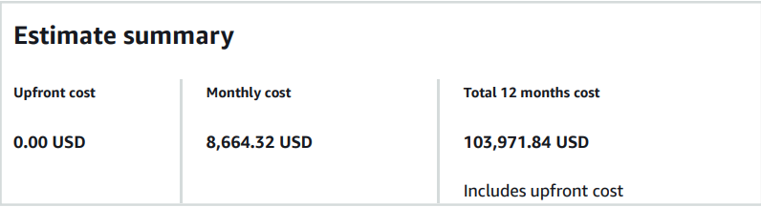

1st line support for 1 year (48 weeks 5 days a week) x2 = 120,000

3rd line support for 1 year (48 weeks 5 days a week) = 84,000

Solutions architect only needed for 3 months (12 weeks 5 days a week) = 60,000

Server migration engineer for 2 months = 26,000

database migration engineer for 2 month = 30,000

**Total cost of support (annually) = 320,000**

**Total cost of support + AWS cost = 423,971.84 per year**

Disclaimer - I am not sure how accurate any of these costs would be in reality.